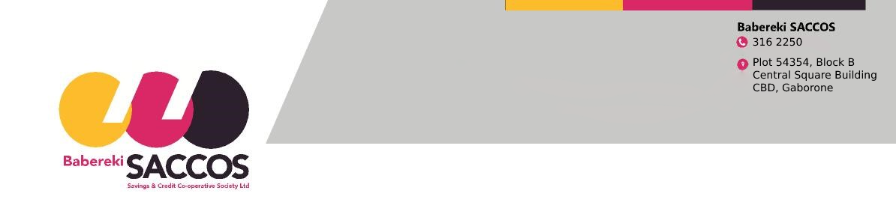

MEMBERSHIP APPLICATION FORM

In making this membership application, I do hereby agree to conform to the society‘s Bye-laws and any amendments thereof.
PERSONAL DETAILS
Surname: |  |  | First Names:
Date of birth: |  |  | Gender: Male ☐ Female ☐
Home Village:
Identity Card No.
Are you a member of another SACCOS? YES NO
Physical Address:
Postal Address:
Contact numbers: | Home: | Cellphone: |  | e-mail:
Civil Status: Single ☐ Married ☐ Divorced ☐ Widowed☐

EMPLOYMENT DETAILS
Government Ministry/Parastatal:
Department:
Designation:

NOMINEES (Person(s) designated to receive funds/benefits in the unfortunate event of loss of life)
NO: | NAME | RELATION | DATE OF BIRTH | ID (OMANG) | CONTACT NO. | %
Applicant’s signature: Date:

AUTHORITY TO MAKE DEDUCTIONS

Monthly Savings.
I………………………………………………….. authorize you to deduct……………….(minimum P100.00) from my monthly salary or direct from my bank account held Bank………………………………………………Account Number…………………………………………………..Branch………………………………………on the ……………of every month towards my savings. Salary payment group 1 or 2 (Tick).

Payment of Shares.

Contributions to be paid through (Tick Appropriate)
Salary Deductions ☐ Bank Deposit ☐ Cash ☐
Indicate the amount to be contributed below in figures and in words
Amount in figures: BWP…………………………………..
Amount in words:…………………………………………………………………………………………..
No. of installments:………………………………………………………………………………

Note: A once-off joining fee of P200.00 will be deducted upon approval of your membership application.
RECRUITER/REFERRAL DETAILS:
Where did you hear about BABEREKI SACCOS:

Website : Social Media: Recruiter:

If Social media,list source.

Recruited by:……………………………………….
Signature of recruiter:…………………………….
Contact details of recruiter: ……………………..
Date:………………………………….

Signature of Applicant……………………………………Date………….………..…………………………….………...

