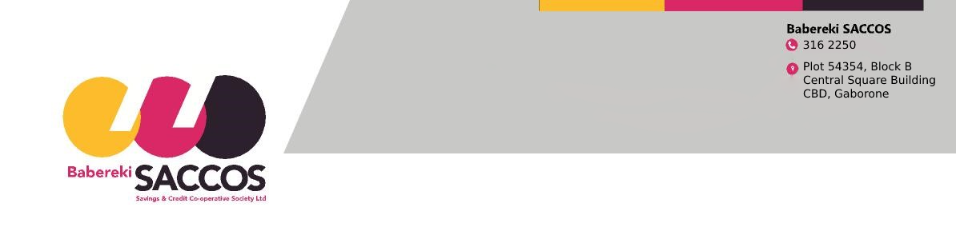

MEMBERSHIP TERMINATION FORM

The Chairperson Babereki SACCOS Box 1708 AAD Poso House Gaborone
I do hereby request to terminate my membership from Babereki SACCOS Limited with effect from . . . . . . . . . . . . . . . . . . . . . . . . . . . . . . . . . . The reason for my withdrawal is. . . . . . . . . . . . . . . . . . . . . . . . . . . . . . . . . . . . . . . . . . . . . . . . . . . . . .
I am FULLY aware that according to the Bye-laws, a member may at any time terminate their membership of the Society by giving a written notice of ninety (90) days.
Personal Account Details
Full Names; | ID/Passport No.
Employer: | Contact No.
Bank Name: | Branch Name:
Branch No. | Account No.

Member Signature; . . . . . . . . . . . . . . . . . . . . . .
Date: . . . . . . . . . . . . . . . . . . . . . . . . . . . . . . .

FOR OFFICIAL USE
Loan Balances: . . . . . . . . . . . . . . . . . . . . . Savings Pre-approval. . . . . . . . . . . . . . . . . . .
Admin fee. . . . . . . . . . . . . . . . . . . . . . . . . . Savings Balance. . . . . . . . . . . . . . . . . . . . . .
Authorized By: . . . . . . . . . . . . . . . . . . . . . . . . Date . . . . . . . . . . . . . Signature: . . . . . . . . Approved/Disapproved: . . . . . . . . . . . . . . . . . . Date ;. . . . . . . . . . . Signature:. . . . . . . . .

